Laporan Praktikum 6

1. Source Code

ModelBuku.php => models

ModelUser.php => models

autoload.php => config

database => config

1. Database

tbl_buku => Pustaka

tbl_kategori => Pustaka

tbl_role => Pustaka

tbl_user => pustaka

1. Capture Output Program

Tabel User

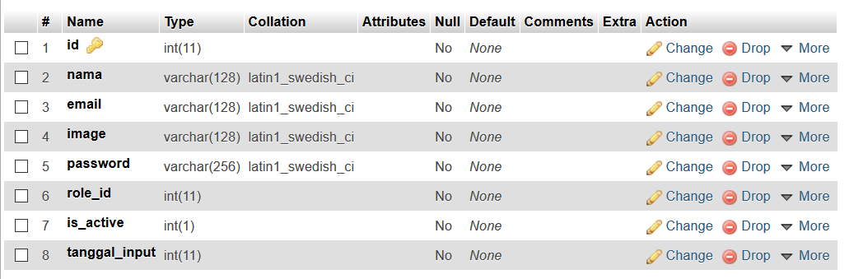

Tabel Role

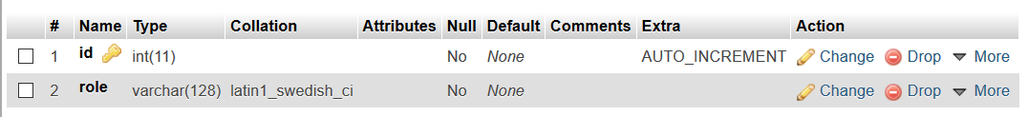

Tabel Kategori

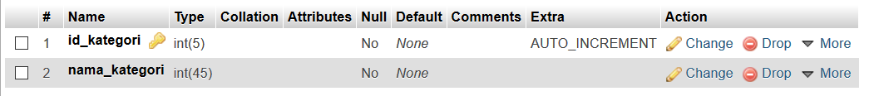

Tabel Buku

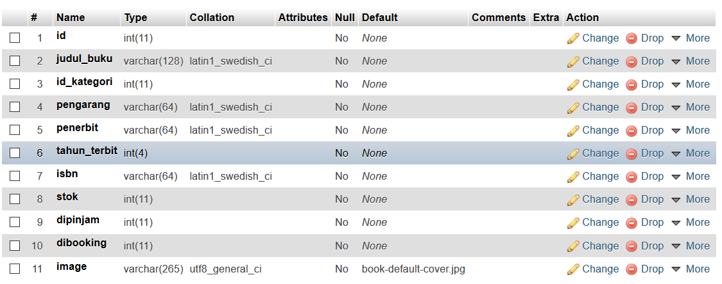

Database Pustaka

